Popularity of Programming Languages Based on User Requirements

Reeshabh Agrawal
Computer Science
New York University
RPA254@nyu.edu
Rahul Joshi
Computer Science
New York University
RJ1022@nyu.edu

Ashish Tyagi
Computer Science
New York University
AT2967@nyu.edu

Abstract—
We have built an analytical tool that uses our proposed metrics to enable different factions of the programming community to make informed choices about the selection of certain programming languages and technologies for use in their day-to-day business. With this tool we would like to enable students, businesses (start-ups and long established companies), trainers and educators to select a particular programming language based on custom factors. We are attempting to provide a selection solution, which will provide clarity to its user. For the above stated purpose we have analyzed and aggregated data from the most popular Q&A websites for programmers – stackverflow.com and most popular source code management website Github.com. We have applied our proposed metrics to the said data to gain meaningful insights based on the user needs.
Powered by Big-Data, Hadoop, Hive, Pig, MapReduce…

Introduction
Many technology blogs and websites rank programming languages based on their popularity. The problem lies with the fact that this ranking is not meaningful to every user in the same manner. For example, a student would like to know the programming languages, which fetches a high remunerating job. Whereas, on the other hand a start-up maybe interested in investing in a technology which has rich open source libraries. Like-wise a long established company would look at the stability of a particular programming language before using it in its systems. Thus, to solve this problem, the requirements of each user have to be dealt with differently. Also, the data source used for the project has to be popular enough to make high claims. Stackoverflow.com became a perfect fit for our project since it is used by a majority of the programming community to solve and seek answers for programming doubts.

Motivation
Technology and software is being used in every walk of life. The requirements have become job specific. Thus, programming languages came to be designed for specific uses, which has resulted in an explosion of number of programming languages. With this explosion in the number of new languages came the dilemma of which language should one choose to do a job when there are many available and each one can do the job well. This might seem to be a trivial question at first but can have a major impact on the overall lifeclye of a software product.
For example let’s say there is a company that needs to implement its new business model software that will be used in every department. First question that comes to the mind is which language to choose? Let’s again assume one chooses VB.net for this purpose. Three years down the line one will realize that VB.net is not so effective anymore with the advent of C# and will be forced to migrate the entire software to C# to keep the maintenance cost within the budget since maintenance demand for VB.net is now much higher than for C#. So even if a language is capable of doing the job it doesn’t mean the company should choose that language. It has to first analyze the demands of the company from that language. If the software is to be maintained regularly then the language should be having a large developer support and should have a stable trend of usage over the past years. Whereas, on the other hand, if the software does not require maintenance the language that is chosen should be analyzed to suit the current requirements.
This decisions of which language to choose can be hard at times and may involve a risk of choosing an unsuitable language because of lack of knowledge about position of that language in the current market. Our sole motivation for this project was to help the stakeholders make an informed decision and to provide them with the means to help select a language. Stackoverflow and Github are the most popular Q&A and code repository websites, respectively. The data from these websites can be harnessed to perform an analytic, which can give trustworthy results. Stackoverflow is the market leader, currently, as a go-to website for the programming community to answer and ask questions. Stackoverflow maintains and provides the data of the traffic that the website receives and meta-data of all the posts in an XML data format. This data is open for download and use on its website. Github also maintains all the data related to the projects hosted on its platform and makes it available for public use. Since, it was established that the data provided by these websites will yield the closest to accurate results, we agreed upon using them to perform the said analytics.

Related Work
There are not many related works based on both Stackoverflow and GitHub data. There are plenty of papers on both of them in isolation. There are a few instances where people have tried to show what are the top and popular languages based on the data from both the websites. Like a popular website Redmonk ^{[5]} presented an excellent charting of top languages based on the two website data. Where on one hand the website did an excellent job on presenting the listing of programming languages the facts represented are not sufficient enough to answer the main question which language to choose when asked from different stakeholders. For example if a company needs to choose a language that has a very stable growth then we simply cannot find this from a static list given here. Similarly if a training company needs to find which languages are new and are sought after by potential developers but don’t have much support yet then this question cannot be answered from these lists. Whereas the analytics produced by this project tries to answer these questions as the analytics not only gives a list of languages but also shows their trends over period of time and trends based on different aspects. Like if a company needs to choose a language that has a stable growth then the analytics can help it by suggesting the languages that have a growing trend over past few years promising that these languages will be a safe choice. On the other hand if a training company wants to select a language that is popular but does not have much support then also the analytics can help answer this by suggesting languages those are having a shooting trend graph in terms of people asking questions about them but at the same time have dipping or very constant and not increasing answers and development graphs. So the analytics produced by this project is based on same data as presented by other sources but is capable of answering much more detailed questions and can help different stakeholders to take an informed decision by showing the different sides of the same data.

Design
StackOverflow and GitHub have huge volume of data that is available for public. GitHub data is well organized and comes and in standard SQL format so it was easy to query the data but StackOverflow’s data dump is in the form of xml files and it needed a bit of extra effort and programming to extract the useful part of the data. Our design was based on two factors. First to efficiently hand big data and run fast algorithms based on MapReduce to extract data and second to join GitHub and StackOverflow data based on programming languages. The figure below shows the broad overview design of the project and depicts the various top level components and their inputs and outputs.
In the initial input phase, project uses two data sources i.e. Stackoverflow site data and GitHub Site data shown in the Data Input section. The data sources are two main files one zip file for Stackoverflow data and SQL data of Github data combined size of entire data set is around 70GB. When uncompressed there are many raw XML files for Stackoverlfow data having all the data in form XML tags of few high level website components like posts, users, Projects and comments etc.
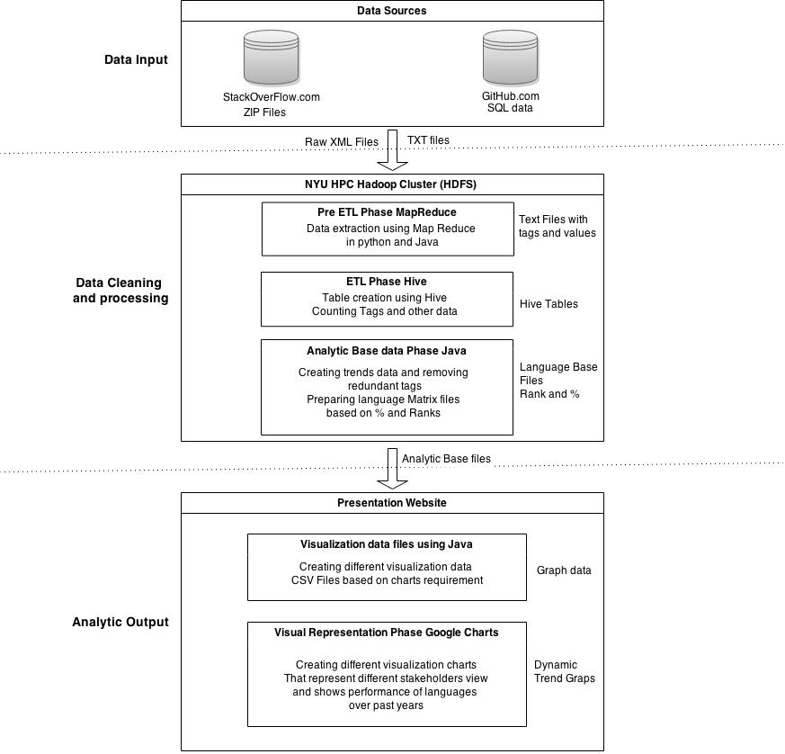
These XML data files and Text files from Github Query processor were then fed to the data cleaning and processing phase where all the magic happens. The data is first passed through a Pre ETL phase where the various XML file of different components are cleaned and then passed through the Map Reduce codes to process them into text files of tags and values where tag being the entity of database tables like ID TimeStamp, ParentID, UserID, CommentID, AnswerID, PostID etc.. These files are in the form of delimited with a special delimiter |~| as the regular delimiter would have failed in these text heavy files. After the pre ETL phase these text files are fed to the ETL phase where all the required data is collected into tables and relations are made and all unwanted data is shredded off or replaced. Like huge TextBody Tags that have the entire text of the Stackoverlflow question are replaced with the list of Languages being used in that question and Tags like date time are converted to just Time so that the files generated will be of smaller size and faster to process. After creation of these relations and tables data is extracted from these tables and Github Text files in form of two CSV files having counts of various parameters of languages like questions, answers, views, scores, projects these CSV files are then fed to the next stage for matrix calculation and tag cleanups.
Once the data is cleaned and collected in two main CSV files it is fed to the Analytics base data phase where all the data is thoroughly scanned using Java code and redundant tags are converted in the same language names. Language data for missing years is replaced with 0 values. Both the CSV files are then converted into a single base findings file having all the parameters counted for a language for each year. After creation of findings CSV it is then further used to calculate the Matrix base data files which are basically two main CSV one on the base of Percentage and another on the base of Ranks. These CSV files contain data for base factors like questions, answers, views and projects converted to % and Ranks. Finally the last overall value field is added to both CSV file and eight new CSV files are generated that contain the data for each stakeholder with overall field value calculated based in the language matrix and added to each file. These eight CSV files serve as core trend data files for the analytics visualization phase.
In the final output phase of the project the core data is first converted into CSV files having year, top 24 Language and overall fields which is then fed to google charts to represent the trends of various languages by Ranks and by % in form of charts providing a much better visual comparison. Then finally these charts are arranged by type of user and type of rating i.e. rank or % and presented in the website to help various users find answer to their requirement based on language trends.

Results
The results were obtained for the following types of users – student, business, start-up and instructor. Ranks based on percentages showed the following results for the student user type – 1.JavaScript 2.Java 3.PHP 4.C# 5.Python. Ranks based on the rank of languages in the individual categories of the number of views, questions, answers and projects for each type of user showed a significant change in the rankings. The results based on ranks for the student user type were as follows – 1.C# 2.Java 3.Javascript 4.PHP 5. Python. For the start-up user type Python was ranked higher than PHP in the rank based result. While C++ can be considered a matured language, for the instructor user type C++ ranked 6th indicating the language’s popularity/need as one of the preferred choices for first timer’s in the programming world.

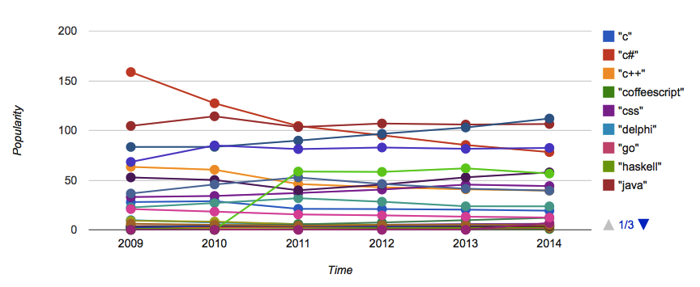
1. Graph for user type based on percentages.

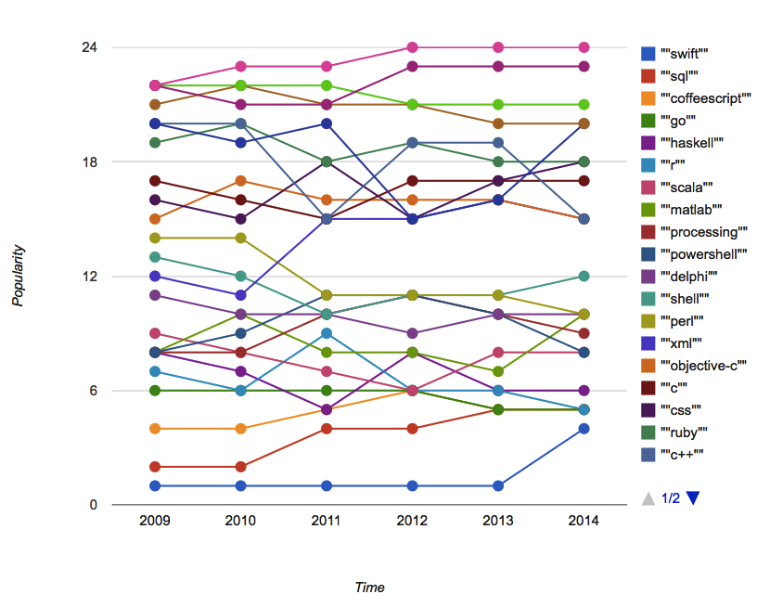
2. Graph for user type based on ranks of languages in individual categories of number of views, questions, answers and projects.

Java received maximum number of view, questions and answers according to the StackOverflow data. The maximum number of projects is in JavaScript according to the Github data. One interesting fact that can be noticed from the StackOverflow is – The views for each of the languages reach the highest peak in the year 2011 which indicates the maturity of the StackOverflow questions’ repository, since the number of views are counted towards the year in which the question was asked.
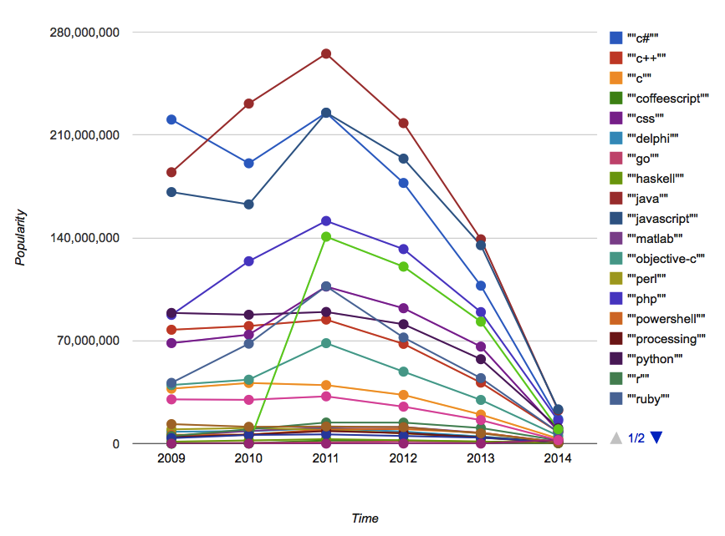
3. Graph for total number of views per language year wise.

One more interesting fact that indicated by the results is that the programming languages adopted by companies like Google, inc. remain popular even after the company adopts newer languages. For example, Python remains popular even after the adoption of Go by Google. Whereas, we see a dip in the popularity of languages like Objective-c as against newer languages like Swift because the use these languages depend solely on popular companies which harness them for use in their tightly controlled product and services.

Future Work
In future the analytic can be further developed and refined to be more flexible for much more specific user requirements. Like based on the base analytic data files there can be further calculations done on some other factors other than just ranking and % and if a user has a much more specific requirement that are not really covered by our matrix then the core data can be used for computation of the matrix that user defines.
There is a significant scope of improvement in the visualization of the analytic that can further enhance the view of findings like the languages that are open source can be graphed in a different chart and when an language is selected from the set of languages then all the parameters that are used for that language like question, answers, projects will be represented on the same graph representing a better comparison and helping better understand the effect of matrix. Also options can be provided for user to select language of their choice and then see a comparison of only those languages instead of viewing all the top 24 languages.
With some small workaround the core data files can be reused in other detailed analytics and predictions like what are the best languages for a particular region and how much scope a language has in terms of expansion in a particular market or region.

Conclusion

Since the start of the project our focus was to come up with answers for questions which languages should a student focus on? Which languages should a startup or a business choose? What are the languages for training institutes and universities should try cash on?
Our initial study was to assess the popularity and maturity of the languages based on the number of questions and answers on StackOverflow and number of projects on GitHub. An important factor that we discovered in StackOverflow data was the total number of views for a question. This helped us factor in the views which also represent that popularity of the language. Based on these four parameters, questions ,answers ,views and projects, we came up with 2 sets of four different metrics for students, businesses, startups and training institutes.
We concluded from the line graphs (refer to the results) that languages were showing uptrends and are on the rise are actually the ones that are being used in the categories currently and these trends can be an indicator for the future.
Another important conclusion is that GitHub and especially StackOverflow data represent a near true picture. Both platforms are mature and the data from these platforms can be trusted to draw reproducible and verifiable insights.

Acknowledgment
We as authors of this paper would like to thank NYU HPC cluster team for their help in setting up the infrastructure for the Hadoop cluster. Also we would like to thank Professor Suzanne McIntosh from NYU SoE Computer Science department for her exceptional support and guidance on every step of this analytics from idea creation to final analytics building.

References
- T. White. Hadoop: The Definitive Guide. O’Reilly Media Inc., Sebastopol, CA, May 2012.
- A. Gates. Programming Pig. O’Reilly Media Inc.,Sebastopol, CA, October 2011.
- J. Dean and S. Ghemawat. MapReduce: Simplified data processing on large clusters. In proceedings of 6th Symposium on Operating Systems Design and Implemenation, 2004.
- S. Ghemawat, H. Gobioff, S. T. Leung. The Google File System. In Proceedings of the nineteenth ACM Symposium on Operating Systems Principles – SOSP ‘03, 2003.
[5] http://redmonk.com/sogrady/2014/01/22/language-rankings-1-14/
- Bogdan Vasilescu, Vladimir Filkov and Alexander Serebrenik. 2013. StackOverflow and GitHub: Associations between software development and crowdsourced knowledge . In 2013 ASE/IEEE International Conference on Social Computing. IEEE, pages 188-195
[7] http://www.gousios.gr/pub/ghtorrent-dataset-toolsuite.pdf

